Guatemala
Work & Witness Teams 2026
A ministry of Baptists on Mission

Baptists on Mission (BOM), working in cooperation with IICD (International Indigenous Community Development) have sent teams to Guatemala since 2011. Volunteer teams are needed throughout 2026 for a variety of mission projects.
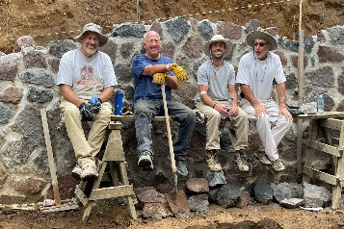
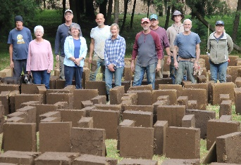
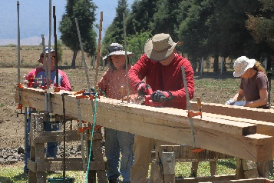
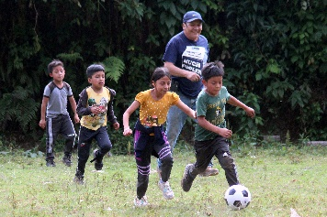

OPPORTUNITIES FOR SERVICE IN 2026:

Construction and Maintenance Teams
The majority of teams are needed throughout the year to assist in the continuation of construction on a director’s house located on the site of the Good Shepherd Center. Teams will have supervision and work with Guatemalans on-site. A variety of construction skills are needed, and there is a job for everyone, regardless of skill level. If needed, teams may also assist with various “home improvement” projects in and around the Good Shepherd Children’s Home facility. Includes $3000 ministry cost per team.

Medical / Dental Teams
Two to three teams are needed to serve in mobile clinics in strategic villages. Teams should be built around 2-3 primary care providers (MDs, DOs, NPs, or PAs) who will see patients. Other team members serve as support personnel, and should be mostly comprised of medical professionals. Medication dispensary should be manned by a health care practitioner (pharmacist preferred, but RNs also work well in this capacity). Teams will need to bring in the medications they will use, counting on seeing at least 30 patients per person; per day. Organization of the clinic is conducted by Dr. Vicki Grossmann (DNP) and Guatemalan leaders. Most teams will stay at the Good Shepherd Center, and prepare meals there, using food that they have purchased once in-town. Includes $2000 ministry cost per team.

School Outreach Teams
A few teams are needed to conduct 2 days of school outreach, similar to Vacation Bible School, with Bible Story, games, crafts, recreation, and music. Students will either be brought in to the Good Shepherd Center for daily activities – or team may travel to areas just outside of Xela. Team will need to bring all VBS-type materials with them. On other days, the team will work on projects at and around the Good Shepherd Center. Includes $2000 ministry cost per team.

Leadership Conference Teams
Two youth leadership and two pastor’s conference teams are needed in 2026. These are small teams – 3-6 total, depending on conference. Each of these events will require a dynamic speaker, worship leader, and 2-3 to help with meal preparation for the participants and team. The program for these events will be planned by missionaries Roger and Vicki Grossmann, who will work with the speaker in preparation. At least one Spanish speaker on the team would be helpful, but not necessarily essential. The partnering church will be asked to contribute $2000 -$2500 toward the operation of the conferences, depending on number of participants.

Children’s Home Staff-Relief Team
One team is needed to run the Good Shepherd Children’s Home for four days and nights while the regular Children’s Home staff are attending a retreat at the Good Shepherd Center. This will entail care for 20-25 children, who range in age from infant to early teens. This will include cooking, cleaning, washing clothes, taking care of infants, toddlers, and school-aged children.. The team will stay at the Good Shepherd Children’s Home for most of the week. Monday will be an orientation day. Need those with patient, loving hearts who will be pro-active in caring for the children. The team should have at least one Spanish speaker and one nurse. Includes a $2000 ministry cost per team.

Children’s Home Assistants
Couples are needed to serve as assistants at the Good Shepherd Children’s Home. Length of service will be from one to three months. Volunteers will assist the Children's Home staff in whatever tasks are needed. This may include cleaning, maintenance, painting, cooking, washing clothes, landscaping, or any other number of tasks. Need those who are self-starters and who can live and work in a non-English speaking environment. Volunteers will live in a small efficiency apartment on the property. Volunteers will purchase their own food and prepare most meals in the apartment. Missionaries will orient the couple in how to utilize local transportation.

Every team will have opportunity to visit the Good Shepherd Children’s Home - and to host a “family night” for the two cottages of children who are living onsite at the Good Shepherd Ministry Center. This will include preparing a meal for the children and house parents, and other forms of entertainment that the team leads in that night.
For more information on the Guatemala Work & Witness Teams contact Mark Abernathy, Baptists on Mission, at:
919=459-5607 mabernathy@ncbaptist.org www.baptistsonmission.org

Team Makeup: Ideal team size is 8-13 members, 13 being the upper limit due to lodging and vehicle limits. Participants must be 18 years
old to participate. Those 15 and up may participate as long as accompanied by a parent or guardian.

Logistics: BOM will arrange airfare, background checks, & insurance for all teams. Lodging, in-country transportation, and ministry-related needs will be arranged by field personnel. Most teams stay at the Good Shepherd Center in Xela.

Airfare Costs: Airfare costs will vary from team to team and generally fall between $800 and $1000 depending upon time of year and seat availability. BOM will secure tickets based on times that we need teams to arrive/depart – always looking for the least expensive option available. (Understand that we have back to back teams throughout much of the year.) Each person must have a valid passport with up to six months remaining.

Field Costs: 2026 Per Person Field Costs Include: Lodging - $33 per night; Insurance (mandatory) - $4.00 per day; Background Check (required) - $10; Van/Driver Cost will be $1400 for teams of 8 and up, divided by number on team. Van/Driver Cost for teams under 8 will be $175 per team member. These costs are sent to the BOM office prior to your trip. Meals - Each person will carry $200 with them in crisp, new bills (preferably 2 on e hundred dollar bills) to be converted once on the field. (You may or may not spend the full $200 on food while in country, and can exchange what is left back to US $)

Team Ministry Costs: Each team will have a ministry cost, which is paid by the church, or divided among the team members. These costs go toward direct ministry expenses that the team will incur while in country, as well as on-going ministry support for Good Shepherd, such as Guatemalan worker salaries (not missionary support), utilities, operational costs, ministry development, etc.

- Contact Baptists on Mission for an update on the status of available trip dates. [919-459-5607 or mabernathy@ncbaptist.org] You can also go to our website at www.baptistsonmission.org (Mission Projects/Outside US/Guatemala)

- Team Leader will claim the project online. He or she will then be sent information on registering their team members. . All team members should be registered no less than 60 days prior to date of departure. Full trip payment is due at least 30 days prior to departure.
____________________________________________________________________________________________________________________________________________________________________________________________________________________________________________________________________________________________________________________________________________________________________________________________________________________________________________________________________________________________________________________________________________________________________

Team # | Date | Team | Project Type | Contact
GU26-101 | January 10-17 | FBC Asheboro -NC | Construction | Jimmy Huffman
GU26-102 | January 17-24
GU26-103 | January 24-31
GU26-105 | February 7-14 | Concord BC – MO | Various | Denise Rhoades
GU26-106 | February 14-21 | Robinhood Road BC – NC | Adobe/Construction | Karla Hackworth
GU26-108 | Feb. 28-Mar 7 | Ridgeway BC – NC | Construction | Mike Leslie
GU26-109 | March 7-14 | Salem Fork BC - NC | Children/Construction | Kay Hamlin
GU26-110 | March 14-21 | Wildwood Fellowship – MO | Various | Russ Ewing
GU26-112 | April 18-25 | Trinity BC (Raleigh) – NC | Construction | Randy McKinney
GU26-113 | Apr 25-May 2 | Mercy Hill BC – NC | Construction | Laurie Taylor
GU25=115 | May 9-16
GU26-118 | May 30-June 6 | Trinity BC – NC | Construction | Grant Stanley
GU26-120 | June 13-20 | Venture Church – NC | Construction | Tim Hall
GU26-121 | June 20-27 | Sulphur Springs BC – NC | Construction | Eric SprinkleJune
GU26-122 | June 27-July4 | Shady Grove BC – NC | Construction | Chris Blanton
GU26-124 | July 11-18 | Ham’s Prairie BC – MO | Construction | Eli Bartley
GU26-125 | July 18-25 | Mercy Hill BC – FL | Construction | Mark Powell
GU26-126 | July 25-Aug 1 | FBC New Bern – NC | Construction | Richard Seagle
GU26-127 | August 1-8 | FBC Asheboro- NC | GSCH Staff Relief | Jimmy Huffman
GU26-129 | August 15-22 | Parkside BC – NC | Construction | Sophia Stewart
GU26-131 | Aug 29 – Sept 5 | Mercy Hill BC – NC | Construction | Laurie Taylor
GU26-134 | September 19-26 | Two Cities Church – NC | Medical | Jason Stopyra
GU26-135 | Sept 26-Oct 3 | Mandarin BC – FL | Construction | Jay Perkins
GU26-136 | October 3-10
GU26-138 | October 17-24 | Salem Fork BC – NC | Children/Construction | Kay Hamlin
GU26-139 | October 24-31
GU26-141 | November 7-14 | Bowen Medical Team | Medical | Toni Bowen
GU26-142 | November 14-21 | Green Level BC – NC | Constr./Student | Jennifer Mobley
GU26-144 | Nov 28-Dec 5
GU26-145 | December 5-12

